**Infrastructure as a Service**

IAAs is a cloud computing model that lets users to access the IT resources like servers, networking, processing, storage, virtual machines, etc. over the Internet. This is possible on a pay-as-you basis. So, the customers can dynamically scale up their resources when needed and scale down them after use.

IAAS is also referred to as Hardware as a Service (HAAS). The primary components of IAAS infrastructure are Storage, Network Hardware, Accompanying Services, Visualization of Hypervisor Layer, and Servers.

IAAS lies at the bottom of the cloud computing architecture, providing the lowest-level control of resources in the cloud. As it provides resources needed to work, it eliminates the cost to be incurred on maintaining the on-premise data center.

IAAS is available in three models. They are:

* **Private Cloud**

This means that the infrastructure is available only in the private workspace of the users, that is at their on-premises.

* **Public Cloud**

This means that the infrastructure is available at the service provider’s or the vendor’s data center.

* **Hybrid Cloud**

This includes both the private and public clouds where the user can select what he needs.

The four services provided by IAAS are:

* **Compute**

The resources for computing, like virtual CPUs and virtual Main Memory are provided to end-users which they can use for the virtual machines.

* **Storage**

Storing of files is easy with IAAS as it provides storage at back-end.

* **Network**

The components like routers, switches, and bridges which are used for the networking purpose in virtual machines are provided by IAAS vendor.

* **Load Balancers**

At infrastructure layer, it provides the load balancers to balance the load on servers and the machines.

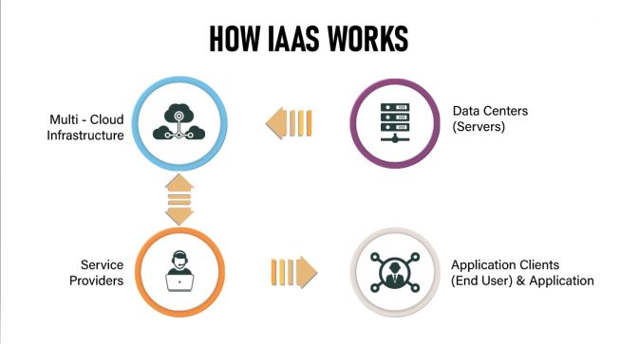

**Figure-1: Working of IAAS**

From the above figure, it is clearly evident that the Clients can use the resources provided by Service Providers and those resources are namely, Data Centers and Multi-Cloud Infrastructure.

**Usecases of IAAS:**

* **Disaster Recovery**

The services provided by IAAS include disaster recovery and backup solutions. This is the essential feature which every organization looks for as it will have a large amount of essential data to store.

* **Application Testing and Development**

Businesses believe IAAS as there is a good security for the applications and SLAs being in place, complex projects can be deployed with a high scalability.

* **Hosting Complex Websites**

As websites will be hosted over Internet in IAAS, they can face no problems in terms of non-static traffic and can have benefits to withstand unforeseen requests.

* **Big Data Analysis**

It is easy to manage, store and analyze big data as IAAS stores large amounts of data and contain many business intelligence tools. So, the organizations can learn from the insights derived and take actions.

**Table-1: Popular vendors of IAAS**

|  |  |
| --- | --- |
| **Vendor** | **Service** |
| Amazon Web Services | EC2 |
| Microsoft Azure | Virtual Machines |
| Google Cloud Platform | Compute Engine |
| Alibaba Cloud | Compute Service |
| IBM Cloud | Private Cloud |

The above tables describe the popular service providers of IAAS and what services they provide using IAAS cloud.

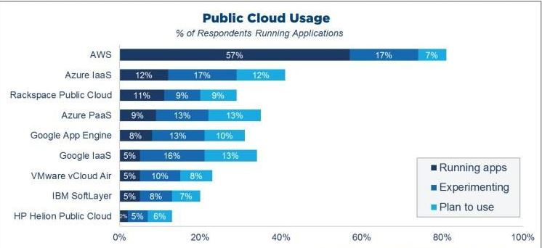

**Figure-2: Analysis of IAAS Public Cloud [1]**

From Figure-2, AWS is the leading organization that utilizes Public Cloud most for running its applications.

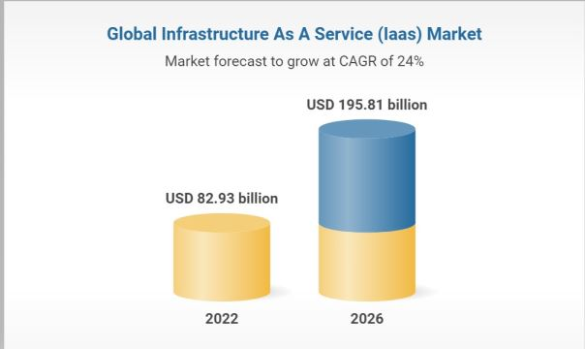

**Figure-3: Forecast of IAAS usage in US [2]**

From Figure-3, the rate of IAAS market in USA is predicted to double when compared to that of 2022 by 2026.

**Conclusion:**

In conclusion, businesses prefer using IAAS as it provides them the basic infrastructure using which they can run their work in the cloud. With the increasing trend of IAAS use, a greater number of high-level projects can be built as the IT team can focus on building applications without thinking about the security and infrastructure.

**References:**

1. RightScale 2018 State of Cloud Report
2. <https://www.researchandmarkets.com/reports/5351796/infrastructure-as-a-service-iaas-global-market> - Research And Markets report on IAAS in global market.

**Please leave the queries and comments in the comment section.**